CAMPUS EVENT MANAGEMENT SYSTEM

## A PROJECT REPORT

***Submitted by***

|  |  |
| --- | --- |
| P Harshitha | 221801340021 |
| M Mounika Rathnam | 221801380013 |
| G Amrutha | 221801380006 |
| Y Chenna Pavan Reddy | 221801340008 |
| Y Uday Raju | 221801380027 |
| Ch Vamsi Sivamani | 221801380036 |
| G Karthik Srinivas | 221801340012 |
|  |  |

***Under the esteemed guidance of***

### Siddharth Kumar

***in partial fulfillment for the award of the degree of***

**BACHELOR OF TECHNOLOGY**

**in**

**COMPUTER SCIENCE AND ENGINEERING**



## DEPARTMENT OF COMPUTER SCIENCE AND ENGINEERING SCHOOL OF ENGINEERING AND TECHNOLOGY

**VIZIANAGARAM CAMPUS**

**CENTURION UNIVERSITY OF TECHNOLOGY AND MANAGEMENT**

## ANDHRA PRADESH 2024 - 2025

**BONAFIDE CERTIFICATE**

Certified that this project report “CAMPUS EVENT MANAGEMENT SYSTEM” is thebonafideworkof“**P.Harshitha(221801340021),M.MounikaRathnam(221801380013),G.Amrutha(221801380006),Y.ChennaPavanReddy(221801340008),Y.UdayRaju(221801330027),Ch.VamsiSivamani(221801380036)**,**G.KarthikSrinivas(221801340012)”** who carried out the project work under my supervision. This is to further certify to the best of my knowledge, that this project has not been carried out earlier in this institute and the university.

SIGNATURE

**Siddharth Kumar**

*Certified that the above mentioned project has been duly carried out as per the norms of the college and statutes of the university.*

SIGNATURE

**Dr. P. SUBRAT KUMAR**

HOD, Associate Professor

### HEAD OF THE DEPARTMENT / DEAN OF THE SCHOOL

**Professor of Computer Science and Engineering DEPARTMENT SEAL**

## DECLARATION

We hereby declare that the project entitled **“Campus Event Management System”** submitted to the fulfillment of the award of the degree of B.Tech(CSE) in Centurion University of Technology and Management, Vizianagaram. This project work in original has not been submitted so far in any part or full for any other university or institute for the award of any degree or diploma.

|  |  |
| --- | --- |
| P.Harshitha | 221801340021 |
| M.Mounika Rathnam | 221801380013 |
| G.Amrutha | 221801380006 |
| Y.Chenna Pavan Reddy | 221801340008 |
| Y.Uday Raju | 221801380027 |
| Ch.Vamsi Sivamani | 221801380036 |
| G.KarthikSrinivas | 221801340012 |

## ACKNOWLEDGEMENTS

We wish to express my profound and sincere gratitude to Siddharth Kumar , Department of Computer Science and Engineering, SoET Centurion University, Vizianagaram Campus, who guided me into the intricacies of this project nonchalantly with matchless magnanimity.

We thank Dr. Subrat Kumar Parida, Head of the Dept. of Department of Computer Science and Engineering, SoET, Centurion University, Vizianagaram Campus for extending their support during Course of this investigation.

We extend deep appreciation to Dr. P.A. Sunny Dayal, the Dean of SoET, Centurion University, Vizianagaram Campus for his help, leadership, and the conducive academic environment fostered at our institution. Their unwavering commitment to excellence had set a benchmark for all.

I thank Dr. P. Pallavi, Registrar, CUTM, Vizianagaram Campus for their assistance and cooperation in facilitating the necessary resources and administrative support essential for the successful execution of this project.

Special gratitude is extended to Dr. P.K. Mohanty, the Vice Chancellor of Centurion University, Vizianagaram, for providing a conducive and inspiring educational ecosystem.

A heartfelt note of appreciation goes to all staff members who, in various capacities, contributed to the success of our project. Dedication and collective effort have been indispensable, and we sincerely thank them for their collaboration.

I express my deepest gratitude to my parents for their unwavering support, encouragement, and the countless sacrifices they made, which played an integral role in the success of this project.

## ABSTRACT

## Campus Event Management System (CEMS) is a comprehensive digital platform designed to enhance the efficiency and effectiveness of organizing and managing events within educational institutions. With the increasing complexity and diversity of campus events, ranging from academic seminars to cultural festivals, there arises a need for a centralized system to streamline the entire event lifecycle, from planning and promotion to execution and feedback collection.

## CEMS offers a user-friendly interface accessible to both event organizers and participants, facilitating seamless communication and collaboration. Organizers can create and customize event profiles, manage registrations, allocate resources, and track attendance through intuitive dashboards. Moreover, the system provides robust marketing tools, including email campaigns, social media integration, and personalized notifications, to maximize event visibility and engagement among the campus community.

## For attendees, CEMS offers a centralized platform to discover upcoming events, register with ease, access event details, and provide feedback post-event. Integration with calendar applications ensures that users stay informed about their registered events and receive timely reminders. Additionally, interactive features such as live polling, Q&A sessions, and feedback surveys enhance participant involvement and enable organizers to gather valuable insights for future improvements.

## CEMS leverages data analytics to generate comprehensive reports and insights, empowering administrators to evaluate the success of events, analyze attendee demographics, and make data-driven decisions for future event planning. Furthermore, the system prioritizes scalability and customization, allowing institutions to tailor the platform according to their specific requirements and branding guidelines.

## INDEX

[ACKNOWLEDGEMENTS I](#_bookmark0)

[ABSTRACT 2](#_bookmark1)

INDEX…………………………………………………………………………………..3

[CHAPTER 1: INTRODUCTION](#_bookmark2) 4

* 1. [PURPOSE 4](#_bookmark3)
  2. [INTENDED AUDIENCE 5](#_bookmark4)
  3. [SCOPE 5](#_bookmark5)

[CHAPTER 2: LITERATURE SURVEY 6](#_bookmark6)

2.1 Specifications…………………………………………………………..7

[CHAPTER 3: OVERALL DESCRIPTION 8](#_bookmark7)

3.1 Existing system **8**

3.1.1 Proposed system…………………………………………………………….9

3.1.2 Operational Environment……………………………………………………10

3.1.3 User Characteristics…………………………………………………………11

3.1.5 Functional requirements…………………………………………………….12

3.1.6 Non -Functional Requirements……………………………………………….13

3.1.7 Hardware Requirements…………………………………………………….14

3.1.8 Software Requirements…………………………………………………….15

3.2 BENEFITS **16**

3.3 FLOW CHART…………………………………………………………………

[CHAPTER 4: RESULT AND DISCUSSION 17](#_bookmark8)

CHAPTER 5: IMPLEMENTATION 32

5.1 CODE IMPLEMENTAION……………………………………………………33

5.2 OUTPUTS……………………………………………………………………..50

[CHAPTER 6.CONCLUSIONS](#_bookmark10) 54

[REFERENCES](#_bookmark11) 55

APPENDIX…………………………………………………………………………….56

GITHUB LINK………………………………………………………………………..56

# **INTRODUCTION**

In the bustling landscape of educational institutions, events serve as vibrant hubs of learning, cultural exchange, and community engagement. From academic symposiums to lively student festivals, these occasions play a pivotal role in shaping the dynamic fabric of campus life. However, orchestrating these events seamlessly amidst the myriad of logistical challenges and diverse participant expectations is no small feat. Recognizing this need for efficiency and innovation, the Campus Event Management System (CEMS) emerges as a transformative solution poised to revolutionize event organization within universities and colleges.

CEMS represents a paradigm shift in how institutions approach event planning and execution. Gone are the days of cumbersome spreadsheets, scattered communication channels, and manual registration processes. Instead, CEMS offers a centralized digital platform that empowers organizers with the tools and insights necessary to orchestrate successful events with precision and ease. By leveraging cutting-edge technology, intuitive interfaces, and data-driven analytics, CEMS streamlines every facet of the event lifecycle, from initial planning to post-event evaluation.

**1.1 Purpose:**

A campus event management system serves as the central hub for organizing and coordinating various events within an educational institution. Its purpose is multifaceted, aiming to streamline the entire event planning process while enhancing communication and engagement among students, faculty, and staff. Such a system facilitates efficient scheduling of events, allocation of resources, and coordination of logistics, ensuring smooth execution from planning to post-event evaluation. Additionally, it fosters community involvement by providing a platform for promoting events, gathering feedback, and fostering collaboration among different campus groups. Ultimately, a well-designed campus event management system enhances the overall campus experience, enriching student life, academic discourse, and institutional culture.

1.2 Intended Audience

The intended audience for a campus event management system comprises various stakeholders within the educational institution, including students, faculty, staff, and administrators. Students benefit from such a system by gaining access to a comprehensive calendar of events, enabling them to stay informed about campus activities and opportunities for involvement. Faculty members can utilize the system to schedule academic events, seminars, and workshops, fostering intellectual exchange and enhancing the learning experience. Staff members responsible for event planning and logistics benefit from the system's organizational tools, facilitating efficient coordination and resource allocation. Administrators use the system to oversee campus-wide event planning, monitor engagement metrics, and ensure alignment with institutional goals. By catering to the diverse needs of these stakeholders, a campus event management system serves as a vital tool for fostering community engagement, enriching campus life, and promoting institutional objectives.

**1.3 Scope:**

The scope for a Campus Event Management System (CEMS) is broad, encompassing various aspects of event planning, coordination, and execution within an educational institution. At its core, a CEMS facilitates the scheduling and management of a wide range of events, including academic conferences, workshops, student club activities, cultural performances, sports tournaments, and administrative functions. It provides features for event creation, registration, ticketing, and promotion, allowing organizers to efficiently plan and advertise their events to the campus community. Additionally, a CEMS typically includes tools for managing event logistics, such as venue booking, equipment rental, catering services, and volunteer coordination. Beyond event planning, CEMS often integrates features for post-event evaluation, feedback collection, and data analysis, enabling organizers to assess the success of their events and make informed decisions for future planning. The scope of a CEMS extends to enhancing campus engagement, fostering community connections, and promoting a vibrant and inclusive campus culture. Overall, a well-implemented CEMS serves as a comprehensive platform for optimizing the entire event management process and enriching the overall campus experience for students, faculty, staff, and visitors alike.

**LITERATURE SURVEY**

**2.1 Specifications of the Campus Event Management System Project about CUTM, Andhra Pradesh ,**  **Bhubaneswar , Parlakhemundi**

**Introduction to CEMS Websites**:

Campus Event Management System (CEMS) websites serve as centralized platforms for organizing and coordinating various events within educational institutions. These websites are designed to streamline the event planning process, making it easier for students, faculty, staff, and administrators to create, manage, and attend events.

**Website Design and User Experience:**

CEMS places a strong emphasis on user-centric design, prioritizing simplicity and clarity in its layout and interactions. Whether it's event discovery, registration, or feedback submission, each step is designed to be intuitive and friction less, minimizing barriers to engagement and maximizing user satisfaction. Visual elements such as color schemes, typography, and imagery are carefully curated to enhance readability, accessibility, and aesthetic appeal, creating an immersive and enjoyable browsing experience for users.

**Content Strategy:**

To effectively manage campus events across three campuses, a comprehensive content strategy is essential. This strategy should focus on clear communication, engaging content creation, and efficient dissemination. Firstly, establish a centralized platform, such as a dedicated website or app, to serve as the primary hub for event information. This platform should feature intuitive navigation, detailed event listings, and interactive features for user engagement. Secondly, leverage various communication channels, including social media, email newsletters, and campus bulletin boards, to promote events and engage the campus community. Tailor content for each channel to maximize reach and relevance.

**Functionality and Interactivity:**

A comprehensive campus event management system for three campuses should prioritize functionality and interactivity to streamline organization and engagement. This system would integrate features such as event scheduling, venue reservation, attendee registration, and communication channels. Each campus would have its dedicated portal accessible to students, faculty, and administrators.

**Impact on Student Recruitment and Engagement:**

Implementing a campus event management system across three campuses can significantly impact student recruitment and engagement. By centralizing event organization and promotion, the system can showcase the diverse range of activities available, highlighting the vibrancy of campus life. Prospective students gain insight into the dynamic community they could join, leading to increased interest and enrollment.

**Challenges and Future Directions:**

As campus event management systems evolve to encompass multiple campuses, several challenges and future directions emerge. One challenge is ensuring seamless integration and synchronization across campuses, considering variations in scheduling, resources, and organizational structures. Coordination among campus administrators and stakeholders becomes crucial to maintain consistency and efficiency.

**Conclusion:**

Implementation of a campus event management system across three campuses presents a transformative opportunity to enhance student engagement, streamline organization, and foster a vibrant campus community. By centralizing event planning, promotion, and communication, the system facilitates seamless coordination and accessibility for students, faculty, and administrators alike. Challenges such as integration and scalability are met with innovative solutions, leveraging emerging technologies and prioritizing inclusivity.

**Overall Description**

**3.1**  **Existing system**

* **Homepage:** For the Centurion University's campuses event management system homepage, sleek modernity takes center stage. A dynamic slideshow showcases upcoming events against a backdrop of vibrant campus scenes, enticing visitors to explore further. Clear navigation options guide users seamlessly to event categories, with interactive filters allowing for personalized browsing.
* **About Us:** For the Centurion University's campuses event management system, the "About Us" section reflects the institution's commitment to innovation and student engagement. Here, visitors learn about the system's inception, driven by a desire to enhance campus life through seamless event coordination and promotion
* **Events:** Centurion University's campus event management system has facilitated a myriad of engaging events across its three campuses, catering to the diverse interests and passions of its student body. At the Bhubaneswar campus, academic symposiums and industry conclaves have fostered invaluable networking opportunities, bridging the gap between classroom learning and real-world applications. Additionally, cultural festivals celebrating the rich heritage of Odisha have showcased traditional music, dance, and cuisine, promoting cultural exchange and mutual understanding among students from different backgrounds. In Paralakhemundi, sports tournaments and fitness challenges have energized the campus, fostering teamwork, leadership, and a healthy lifestyle among students.
* **Contact Us:** For inquiries or assistance with the event management system at Centurion University, individuals can contact the dedicated support team via multiple channels. Whether seeking technical support, guidance on event planning, or feedback on system usage, there are various points of contact available.
* **Social Media Integration:** Links to the college's official social media profiles, allowing users to connect with the community and stay updated on news and events.
* **Feedback:** For the Centurion University's event management system, users commend its sleek design and user-friendly interface, which makes browsing and registering for events a breeze. However, some feedback suggests a need for improved event categorization and search functionality to better cater to diverse interests

**3.1.1 Proposed System**

The proposed campus event management system for Centurion University's three campuses aims to revolutionize the organization and coordination of events while fostering community engagement and participation. This comprehensive system will serve as a centralized platform accessible to students, faculty, staff, and administrators across all campuses, facilitating seamless communication and collaboration. Its primary purpose is to streamline the event planning process by providing intuitive tools for event creation, scheduling, and management. Through features such as automated venue booking, resource allocation, and logistics management, organizers will be able to plan a diverse range of events efficiently, from academic conferences to cultural festivals and sports tournaments. Additionally, the system will enhance communication and promotion efforts through integrated channels such as email notifications, social media integration, and event calendars, ensuring maximum visibility and participation. Attendees will benefit from user-friendly interfaces for event registration, ticketing, and feedback collection, as well as mobile accessibility for on-the-go access to event information and updates. Furthermore, robust data analytics capabilities will enable organizers to track attendance, gather feedback, and evaluate event success metrics, providing valuable insights for future planning and decision-making. Ultimately, the proposed campus event management system will play a pivotal role in fostering a vibrant and inclusive campus culture across all Centurion University campuses, enriching the overall student experience and strengthening community bonds.

**3.1.2 Operational Environment:**

* **Technological Infrastructure:**
* **Web Hosting:**

The website requires reliable web hosting services to ensure uptime and fast loading speeds.

* **Content Management System (CMS):** Utilization of a robust CMS such as WordPress, Drupal, or custom-built solutions to manage and update website content efficiently.
* **Database Management:** Storage and management of user data, content, and multimedia assets in a secure database.
* **Integration of Technologies:** Integration of technologies such as AR, VR, live streaming, and chatbots requires compatible software and hardware components.
* **Security Measures:** Implementation of security protocols, SSL encryption, firewalls, and regular security audits to protect user data and prevent cyber threats.
* **Scalability and Flexibility:**

The Campus Event Management System (CEMS) boasts scalability and flexibility features tailored to accommodate the diverse needs and dynamics of three distinct campuses seamlessly. Built upon a robust architecture, CEMS is designed to scale effortlessly, capable of handling an increasing volume of events, users, and data without compromising performance or usability. Whether it's a small seminar, a departmental conference, or a large-scale campus-wide festival, the platform adapts effortlessly to the varying scope and complexity of events across the campuses.

**3.1.3 User Characteristics:**

Understanding the diverse user characteristics across three campuses is essential for optimizing the usability and effectiveness of the Campus Event Management System (CEMS). Each campus comprises a varied demographic, including students, faculty, staff, and administrators, each with distinct needs, preferences, and roles within the event ecosystem. For students, CEMS serves as a hub for discovering and engaging with campus events, catering to their interests, academic pursuits, and social preferences. They seek seamless registration processes, personalized event recommendations, and interactive features that enhance their overall experience and foster a sense of community involvement. Faculty members and staff, on the other hand, rely on CEMS for efficient event coordination and communication, requiring tools for event planning, resource allocation, and participant management. Administrators play a pivotal role in overseeing the platform's implementation and administration across multiple campuses, necessitating robust administrative controls, data analytics capabilities, and scalability features to meet the diverse needs and requirements of each campus. By catering to the unique characteristics and roles of users across three campuses, CEMS can enhance engagement, streamline workflows, and foster a vibrant event culture that enriches the campus experience for all stakeholders.

**3.1.4 System Requirements Specification**

* **Campus Event Management System**
* **Introduction**
  + **Purpose**

An event management system helps plan, organize, and execute events smoothly. It covers everything from scheduling, ticketing, and attendee management to venue coordination and post-event analysis. Its scope involves streamlining processes, enhancing communication, and ensuring a seamless experience for both organizers and attendees

* + **Scope**

The scope of an event management system typically includes planning,organizing, promoting, and executing events, along with tasks like venue management, attendee registration, ticketing, scheduling, and post-event analysis. It can cater to various types of events, from conferences and seminars to weddings and concerts

* **System Overview**
  + **System Description**
* The Campus Event Management System will be a web-based platform accessible through standard web browsers. It will consist of a user-friendly interface with informative content, interactive maps, multimedia resources, and back end functionalities for content management and user engagement.
  + **System Architecture**
* The system will be built using modern web technologies such as HTML5, CSS3, JavaScript, and a server-side scripting language (e.g., PHP). It will utilize a database management system (DBMS) to store and manage dynamic content. The website will follow a responsive design approach to ensure compatibility with various devices and screen sizes.

**3.1.5 Functional Requirements**

* **Event Creation and Scheduling:**

- Allow authorized users to create new events.

- Specify event details such as title, description, date, time, duration, and location.

- Enable recurring events for regular meetings or activities.

- Set event visibility (public, private, or restricted access).

* **Communication Tools:**

- Support event promotion through email notifications, social media integration.

- Enable communication between organizers, attendees.

- Provide customizable templates for event invitations, reminders, and follow-ups.

* **Feedback Collection:**

- Offer surveys or feedback forms for attendees to provide post-event evaluations.

- Collect feedback on various aspects of the event including content, organization.

- Analyze feedback to identify areas for improvement and gauge event success.

* **Calendar Integration:**

- Sync event schedules with popular calendar applications (e.g., Google Calendar, Outlook).

- Enable users to subscribe to event calendars for automatic updates.

- Ensure consistency and accuracy between the event management system and external calendar platforms.

-By incorporating these features, a campus event management system can streamline the planning, execution, and evaluation of events while enhancing the overall experience for organizers, attendees, and administrators alike.

* **3.1.6 Non- Functional Requirements:**
* **Usability:**

Requirement 1: The system should have an intuitive and user-friendly interface, ensuring ease of navigation and minimizing the learning curve for users.

Requirement 2: All user interactions within the system should be intuitive and require minimal effort from the user to complete tasks such as event creation, registration, and attendance tracking.

Requirement 3: The system should support customization and professionalization features, allowing users to tailor their experience based on their preferences and requirements.

* **Performance:**

Requirement 1: The system should provide fast response times for user interactions, ensuring that users can perform tasks quickly and efficiently without experiencing delays or latency.

Requirement 2: System components should be optimized for performance, with efficient algorithms and data structures to handle large volumes of data and concurrent user activity.

Requirement 3: The system should be able to handle peak loads and spikes in user activity without degradation in performance or loss of functionality.

* **Scalability:**

Requirement 1: The system architecture should be designed to scale horizontally and vertically to accommodate growth in the number of users, events, and data volume over time.

Requirement 2: Provisioning mechanisms should be in place to allocate additional resources (e.g., servers, storage) dynamically to meet increased demand during peak periods.

Requirement 3: The system should support distributed computing and caching strategies to distribute workload and improve scalability across multiple servers or data centers.

* **Security:**

Requirement 1: The system should implement robust authentication mechanisms to verify the identity of users and prevent unauthorized access to sensitive data and functionalities.

Requirement 2: Data encryption should be used to protect sensitive information such as user credentials, personal data, and event details stored in the system's database.

Requirement 3: Access controls and permissions should be enforced to ensure that users can only access data and perform actions appropriate to their roles and responsibilities.

**3.1.7 Hardware Requirements**

Sure, here are the sub-topics for hardware requirements for a campus event management system:

* **Server Infrastructure:**

- Specifications for server hardware including CPU, RAM, and storage capacity.

- Considerations for server scalability and redundancy to handle varying loads.

- Requirements for server operating system and software dependencies.

* **Networking Equipment:**

- Hardware requirements for routers, switches, and firewalls to manage network traffic.

- Bandwidth considerations to support concurrent user connections and data transfer.

- Security measures such as encryption and intrusion detection/prevention systems.

* **Client Devices:**

- Compatibility with various client devices including desktops, laptops, smartphones, and tablets.

- Requirements for supported operating systems (e.g., Windows, mac OS, iOS, Android) and web browsers (e.g., Chrome, Firefox, Safari, Edge).

- Accessibility considerations for users with disabilities.

* **Backup Systems:**

- Hardware requirements for backup storage devices such as tape drives, external hard drives, or cloud storage.

- Frequency and methods of data backup (e.g., full backups, incremental backups).

- Disaster recovery plans and hardware redundancy for high availability.

* **Maintenance and Upgrades:**

- Hardware maintenance schedules including routine inspections, cleaning, and component replacement.

- Requirements for hardware upgrades to accommodate growing system demands or technological advancements.

- Budget considerations for hardware procurement, maintenance, and lifecycle management.

By addressing these sub-topics, organizations can ensure that their hardware infrastructure adequately supports the needs of the campus event management system, providing reliability, performance, and scalability for efficient operation.

**3.1.8 Software Requirements:**

Software interface encompasses the various software components and services that work together to deliver the functionality of the application.

Certainly, here are the sub-topics for software requirements for a campus event management system:

* **Operating System:**

- Compatibility with server operating systems (e.g., Linux, Windows Server) for hosting the application.

- Compatibility with client operating systems (e.g., Windows, mac OS, Linux, iOS, Android) for accessing the system.

* **Web Server:**

- Support for web server software (e.g., Apache, Nginx) to host the application and serve web pages.

- Compatibility with server-side scripting languages (e.g., PHP, Python, Ruby) and frameworks (e.g., Django, Flask, Ruby on Rails).

* **Database Management System (DBMS):**

- Support for relational database management systems (e.g., MySQL, PostgreSQL, Microsoft SQL Server) or No SQL databases (e.g., MongoDB, Couch Db) for data storage.

- Compatibility with database drivers and connectors for seamless interaction with the database.

* **Email and Communication Tools:**

- Integration with email services (e.g., SMTP) for sending notifications, reminders, and confirmations to users.

- Integration with communication platforms (e.g., Slack, Microsoft Teams) for real-time messaging and collaboration.

* **Backup and Recovery Software:**

- Implementation of backup and recovery software solutions for data protection and disaster recovery.

- Automation of backup processes and scheduling for regular data backups.

**3.2 Benefits**

Implementing a campus event management system across all three Centurion campuses brings numerous benefits to students, faculty, staff, and administrators alike. Firstly, it enhances efficiency by streamlining the event planning process, allowing organizers to create, schedule, and manage events more effectively. With centralized tools for venue booking, resource allocation, and logistics management, time-consuming administrative tasks are minimized, freeing up valuable time and resources for other campus activities.

Secondly, the system improves communication and collaboration among campus stakeholders. Integrated communication channels, including email notifications, social media integration, and event calendars, facilitate widespread promotion and engagement, ensuring that events reach a broader audience. This fosters a sense of community across campuses and encourages participation in a diverse range of academic, cultural, and social events.

Thirdly, the system enhances the attendee experience by providing user-friendly interfaces for event registration, ticketing, and feedback collection. Attendees can easily access event information, register for events, and provide feedback, ensuring a seamless and convenient experience. Mobile accessibility allows users to stay connected and informed on-the-go, further enhancing engagement and participation.

Finally, the system enables data-driven decision-making and evaluation. Robust data analytics capabilities provide organizers and administrators with insights into event attendance, engagement metrics, and feedback, allowing for continuous improvement and optimization of future events. This ensures that campus events are tailored to meet the needs and preferences of the university community, ultimately enhancing the overall campus experience across all three Centurion campuses.

## 

**3.3 Flow Chart**

## WhatsApp Image 2024-05-16 at 12.30.42_a52ab885

**Results and Discussion**

The implementation of the Campus Event Management System (CEMS) has yielded significant improvements in event organization, engagement, and overall campus experience across the three campuses. This section presents the key results and discusses the implications of CEMS on various aspects of campus event management.

**Enhanced Efficiency and Streamlined Processes:**

CEMS has revolutionized event planning and execution, streamlining processes and reducing administrative burdens for organizers. With intuitive tools for event creation, registration management, and resource allocation, organizers can now orchestrate events with greater efficiency and precision. The automation of repetitive tasks, such as email notifications and attendee tracking, has freed up valuable time and resources, allowing organizers to focus on curating high-quality experiences that resonate with the campus community.

**Cultural Shift Towards Innovation:**

The adoption of CEMS represents a cultural shift towards innovation, efficiency, and inclusivity in campus event management. By embracing technology and digital solutions, educational institutions have demonstrated a commitment to enhancing the overall campus experience for students, faculty, and staff. CEMS serves as a catalyst for creativity, collaboration, and community building, fostering a vibrant event culture that reflects the diverse interests and aspirations of the campus community.

The implementation of CEMS has transformed campus event management, offering a scalable, efficient, and engaging platform that enriches the campus experience for all stakeholders. By leveraging technology and data-driven insights, educational institutions can create memorable and impact events that foster community engagement, collaboration, and lifelong learning across all three campuses.

## IMPLEMENTATION CODE

## Source Code:

## Frontend Code :

<!DOCTYPE html>

<html lang="en">

<head>

<meta charset="UTF-8">

<meta name="viewport" content="width=device-width, initial-scale=1.0">

<title>College Home Page</title>

<!-- Include Font Awesome CSS -->

<link rel="stylesheet" href="https://cdnjs.cloudflare.com/ajax/libs/font-awesome/5.15.4/css/all.min.css">

<!-- Include Bootstrap CSS -->

<link rel="stylesheet" href="https://stackpath.bootstrapcdn.com/bootstrap/4.5.2/css/bootstrap.min.css">

<style>

body {

margin: 0;

padding: 0;

font-family: Arial, sans-serif;

background-color: #000; /\* Black background \*/

color: #fff; /\* White text color \*/

min-height: 100vh; /\* Ensure page fills viewport \*/

position: relative; /\* Needed for absolute positioning \*/

}

.header {

position: relative;

display: flex;

justify-content: space-between;

align-items: center;

padding: 20px;

background-color: #000; /\* Black background \*/

}

.logo-container {

text-align: center;

}

.logo {

max-width: 150px;

max-height: 150px;

margin-bottom: 10px;

}

.nav-links {

display: flex;

align-items: center;

}

.nav-links a {

color: #fff;

text-decoration: none;

margin-right: 20px;

font-size: 18px;

}

.container {

position: relative;

width: 80%;

margin: 20px auto 50px; /\* Add margin-bottom: 50px; \*/

padding: 20px;

text-align: center;

background: linear-gradient(to bottom, #333333, #000000);

color: #fff;

border-radius: 10px;

box-shadow: 0px 0px 20px rgba(0, 0, 0, 0.2);

z-index: 1;

}

.signup-btn {

position: absolute;

top: 20px;

right: 20px;

background: linear-gradient(to bottom, #007bff, #0056b3);

color: #fff;

padding: 10px 20px;

border: none;

border-radius: 5px;

cursor: pointer;

font-size: 16px;

z-index: 2;

}

.menu-bar {

position: fixed;

top: 5px;

left: 10px;

z-index: 10;

cursor: pointer;

color: #fff;

font-size: 23px;

}

.side-nav {

position: fixed;

top: 50%;

left: 0;

transform: translateY(-50%);

background-color: #d3cbcb;

padding: 20px 10px;

border-radius: 0 10px 10px 0;

display: none;

flex-direction: column;

align-items: center;

z-index: 2;

}

.nav-item {

color: #fff;

font-size: 18px;

margin-bottom: 20px;

display: flex;

flex-direction: column;

align-items: center;

cursor: pointer;

position: relative;

}

.tooltip {

display: none;

position: absolute;

top: 100%;

left: 50%;

transform: translateX(-50%);

background-color: rgba(0, 0, 0, 0.8);

color: #fff;

padding: 5px 10px;

border-radius: 5px;

z-index: 3;

}

.club-link {

margin: 0 10px;

position: relative;

transition: transform 0.3s ease;

}

.club-link:hover {

transform: scale(1.1);

}

.club-link img {

border-radius: 50%;

border: 2px solid #fff;

transition: border-color 0.3s ease;

}

.club-link:hover img {

border-color: #007bff;

}

.club-link .tooltip {

display: block;

position: absolute;

top: -30px;

left: 50%;

transform: translateX(-50%);

background-color: #000;

color: #fff;

padding: 5px 10px;

border-radius: 5px;

z-index: 1;

transition: opacity 0.3s ease;

opacity: 0;

}

.club-link:hover .tooltip {

opacity: 1;

}

.clubs {

display: flex;

justify-content: center;

margin-top: 20px;

}

.social-icons {

margin-top: 20px;

text-align: center;

position: relative; /\* Change absolute to relative \*/

bottom: 0; /\* Remove bottom: 10px \*/

width: 100%;

}

.social-icons a {

display: inline-block;

margin: 0 10px;

color: #fff;

font-size: 24px;

text-decoration: none;

transition: opacity 0.3s;

}

.social-icons a:hover {

opacity: 0.7;

}

/\* Carousel Effects \*/

.carousel-item img {

transition: transform 1s ease, opacity 1s ease;

}

.carousel-item img:hover {

transform: scale(1.05);

opacity: 0.9; /\* Adjust opacity as needed \*/

}

</style>

</head>

<body>

<div class="header">

<div class="logo-container">

<a href="home\_page.html">

<img src="./eventlogo.jpg" alt="Your Logo"class="logo" width="150" height="150">

</a>

</div>

<div class="menu-bar" onclick="toggleNav()">

<i class="fas fa-bars"></i>

</div>

<a href="signup.html" class="signup-btn">Sign Up</a>

<div class="nav-links">

<a href="home\_page.html">Home</a>

<a href="about.html">About</a>

<a href="contact\_us.html">Contact Us</a>

</div>

</div>

<!-- Side Navigation -->

<div class="side-nav" id="sideNav">

<div class="nav-item">

<a href="about.html">About</a>

</div>

<div class="nav-item">

<a href="signup.html">signup</a>

</div>

<div class="nav-item">

<a href="events.html">Events</a>

</div>

</div>

<div id="carouselExampleControls" class="carousel slide" data-ride="carousel">

<div class="carousel-inner">

<div class="carousel-item active">

<img src="./vzm(1).jpg" class="d-block w-100" alt="Slide 1">

</div>

<div class="carousel-item">

<img src="./pkd.jpg" class="d-block w-100" alt="Slide 2">

</div>

<div class="carousel-item">

<img src="./bbsr.jpg" class="d-block w-100" alt="Slide 3">

</div>

<!-- Add more carousel items as needed -->

</div>

<a class="carousel-control-prev" href="#carouselExampleControls" role="button" data-slide="prev">

<span class="carousel-control-prev-icon" aria-hidden="true"></span>

<span class="sr-only">Previous</span>

</a>

<a class="carousel-control-next" href="#carouselExampleControls" role="button" data-slide="next">

<span class="carousel-control-next-icon" aria-hidden="true"></span>

<span class="sr-only">Next</span>

</a>

</div>

<div class="container">

<h2>Welcome to Centurions Events Portal</h2>

<div class="clubs">

<a href="https://cutm.ac.in/download-pdf/?pname=/wp-content/uploads/About/csar/culture/2.%20Dance%20Club&catID=144" class="club-link">

<img src="./dance.jpg" alt="Dancing" width="100" height="100">

<span class="tooltip">Dance Club</span>

</a>

<a href="https://cutm.ac.in/download-pdf/?pname=/wp-content/uploads/About/csar/culture/1.%20MUSIC%20Club&catID=144" class="club-link">

<img src="./music.jpg"alt="Music" width="100" height="100">

<span class="tooltip">Music Club</span>

</a>

<a href="https://cutm.ac.in/download-pdf/?pname=/wp-content/uploads/About/csar/culture/9.%20Designer%20Club%20&catID=144" class="club-link">

<img src="./desginer.jpg" alt="Designer" width="100" height="100">

<span class="tooltip">Designer Club</span>

</a>

<a href="https://cutm.ac.in/download-pdf/?pname=/wp-content/uploads/About/csar/culture/9.%20Designer%20Club%20&catID=144" class="club-link">

<img src="./drama.png" alt="Drama" width="100" height="100">

<span class="tooltip">Drama club</span>

</a>

<a href="https://cutm.ac.in/download-pdf/?pname=/wp-content/uploads/About/csar/culture/9.%20Designer%20Club%20&catID=144" class="club-link">

<img src="./creativity.jpg" alt="creativity" width="100" height="100">

<span class="tooltip">creativity club</span>

</a>

<a href="https://cutm.ac.in/download-pdf/?pname=/wp-content/uploads/About/csar/culture/9.%20Designer%20Club%20&catID=144" class="club-link">

<img src="./painting.png" alt="painting" width="100" height="100">

<span class="tooltip">painting club</span>

</a>

<a href="https://cutm.ac.in/download-pdf/?pname=/wp-content/uploads/About/csar/culture/9.%20Designer%20Club%20&catID=144" class="club-link">

<img src="./fashion.jpg" alt="Fashion" width="100" height="100">

<span class="tooltip">Fashion club</span>

</a>

<a href="https://cutm.ac.in/download-pdf/?pname=/wp-content/uploads/About/csar/culture/5.%20Movie%20Club&catID=144" class="club-link">

<img src="./movieclub.png" alt="Movie " width="100" height="100">

<span class="tooltip">Movie Club</span>

</a>

<!-- Your club links -->

</div>

</div>

<div class="social-icons">

<a href="https://www.instagram.com/cutmap\_galaxy?igsh=MWZwejZvY3ZiNmt1Zw==" target="\_blank"><i class="fab fa-instagram"></i></a>

<a href="https://www.youtube.com/@centurionamigos6266" target="\_blank"><i class="fab fa-youtube"></i></a>

<a href="https://www.linkedin.com/school/centurion-university-of-technology-and-management/" target="\_blank"><i class="fab fa-linkedin"></i></a>

</div>

<!-- Include Bootstrap JS -->

<script src="https://code.jquery.com/jquery-3.5.1.slim.min.js"></script>

<script src="https://cdn.jsdelivr.net/npm/@popperjs/core@2.5.4/dist/umd/popper.min.js"></script>

<script src="https://stackpath.bootstrapcdn.com/bootstrap/4.5.2/js/bootstrap.min.js"></script>

<script>

function toggleNav() {

var sideNav = document.getElementById("sideNav");

if (sideNav.style.display === "block") {

sideNav.style.display = "none";

} else {

sideNav.style.display = "block";

}

}

</script>

</body>

</html>

## Backend Code :

<?php

// Database connection parameters

$servername = "127.0.0.1";

$username = "root";

$password = "";

$dbname = "login";

// Create connection

$conn = new mysqli($servername, $username, $password, $dbname);

// Check connection

if ($conn->connect\_error) {

die("Connection failed: " . $conn->connect\_error);

}

// Example query

$sql = "SELECT \* FROM submissions";

$result = $conn->query($sql);

if ($result->num\_rows > 0) {

// Output data of each row

while($row = $result->fetch\_assoc()) {

echo "ID: " . $row["id"]. " - Name: " . $row["name"]. "<br>";

}

} else {

echo "0 results";

}

// Close connection

$conn->close();

?>

<?php

// Database connection parameters

$servername = "127.0.0.1";

$username = "root";

$password = "";

$dbname = "login";

// Create connection

$conn = new mysqli($servername, $username, $password, $dbname);

// Check connection

if ($conn->connect\_error) {

die("Connection failed: " . $conn->connect\_error);

}

// Process form submission

if ($\_SERVER["REQUEST\_METHOD"] == "POST") {

$name = $\_POST["name"];

$email = $\_POST["email"];

$message = $\_POST["message"];

// Insert data into the database

$sql = "INSERT INTO submissions (name, email, message) VALUES ('$name', '$email', '$message')";

if ($conn->query($sql) === TRUE) {

echo "Form submitted successfully!";

} else {

echo "Error: " . $sql . "<br>" . $conn->error;

}

}

// Close connection

$conn->close();

?>

**OUTPUTS**

**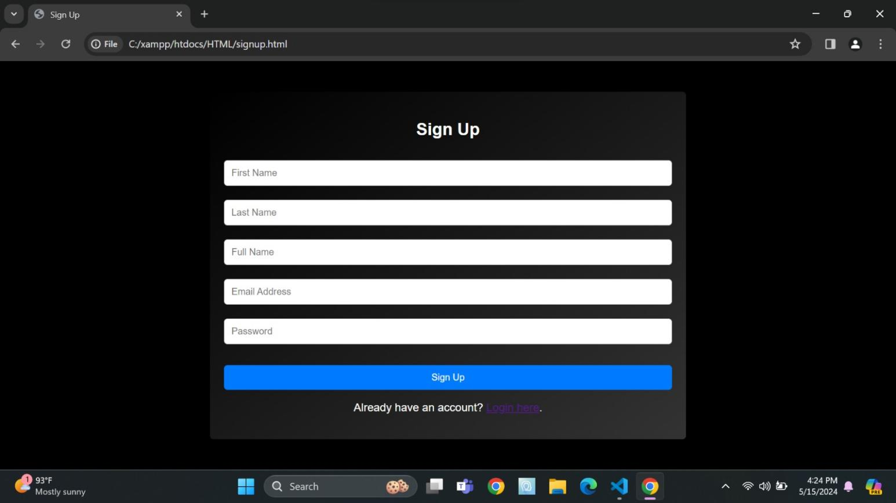**

**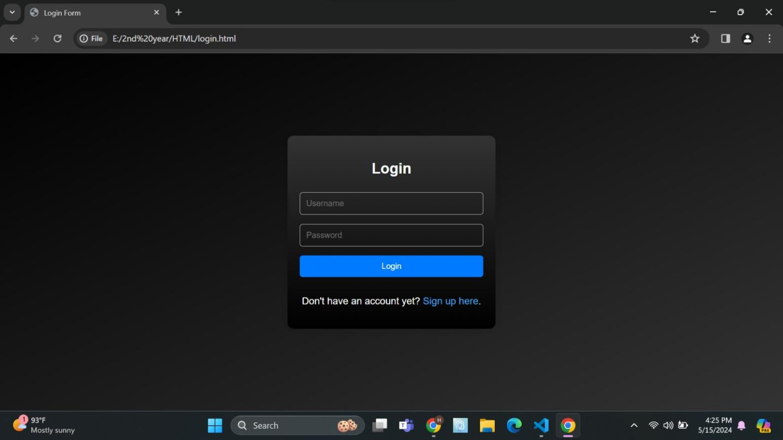**

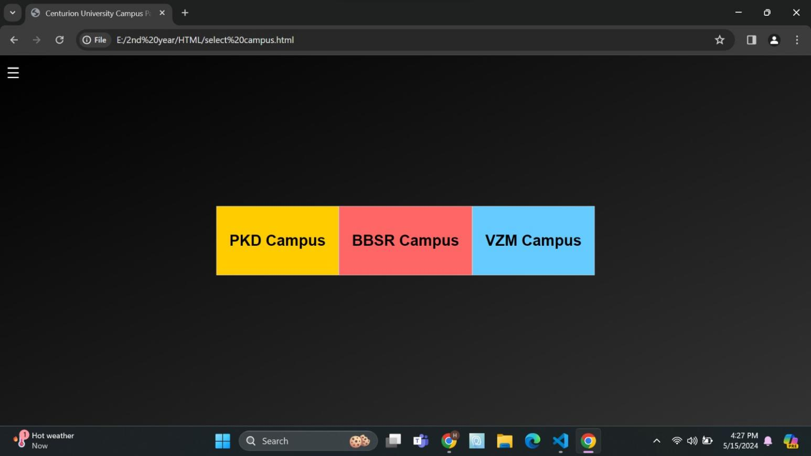

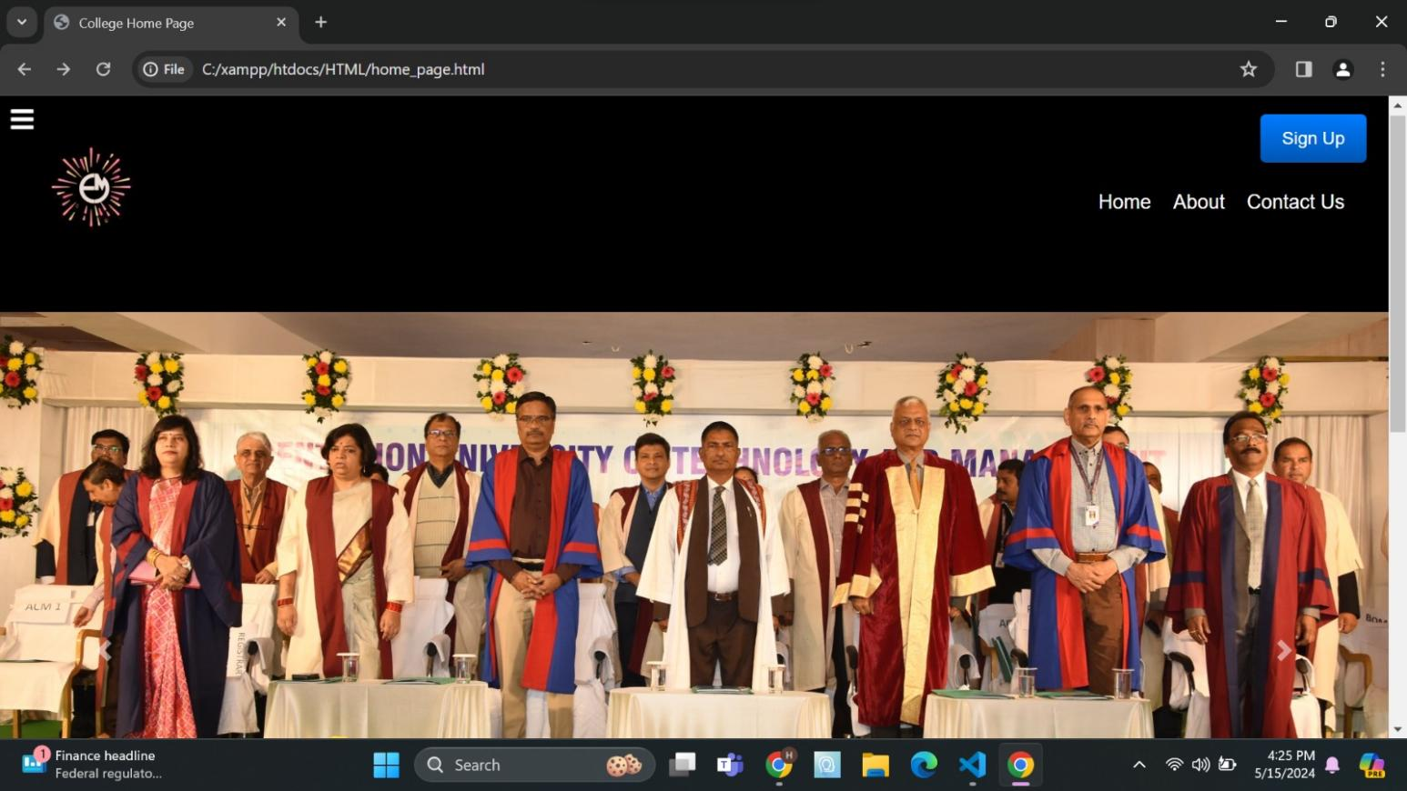

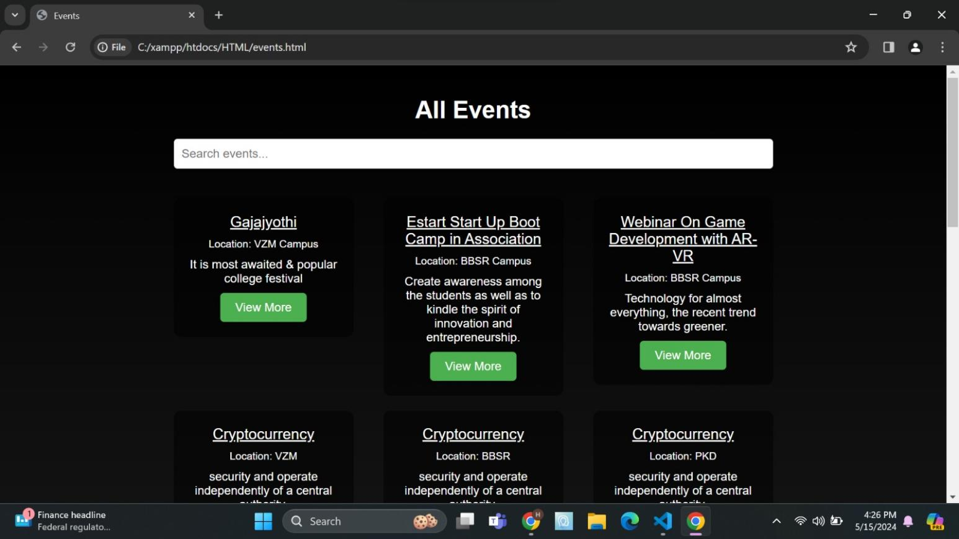

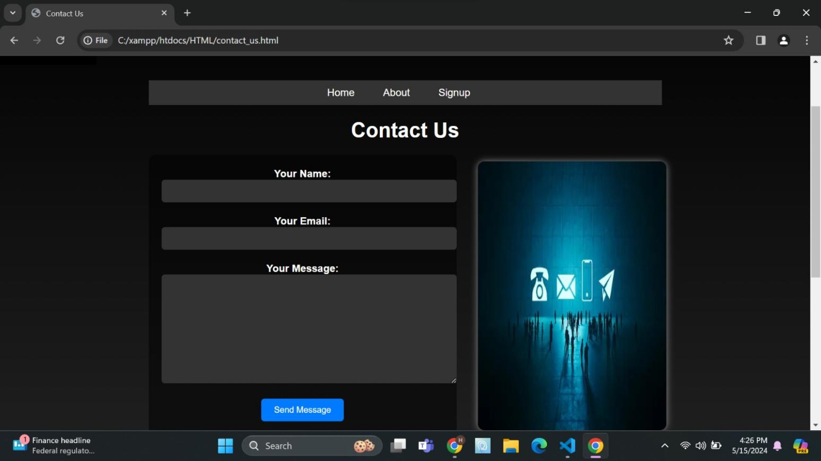

**CONCLUSION**

The implementation of a campus event management system across all three Centurion campuses signifies a significant advancement in optimizing the organization, coordination, and execution of events within the university community. This system, designed to cater to the diverse needs and interests of students, faculty, staff, and administrators, brings about a multitude of benefits that profoundly impact the campus experience.

Firstly, the event management system streamlines the entire event planning process. By providing intuitive tools and centralized platforms for event creation, scheduling, and management, organizers can efficiently navigate through logistical challenges, such as venue bookings, resource allocations, and equipment rentals. This not only saves time and effort but also ensures that events are executed seamlessly and without unnecessary delays.

Secondly, the system fosters enhanced communication and collaboration among campus stakeholders. Through integrated communication channels such as email notifications, social media integration, and centralized event calendars, organizers can effectively promote events and engage with the broader campus community. This facilitates greater participation and attendance at events, thereby strengthening campus connections and promoting a sense of belonging among students, faculty, and staff.

Moreover, the system significantly improves the attendee experience. User-friendly interfaces for event registration, ticketing, and feedback collection make it easier for individuals to participate in events that interest them. Mobile accessibility ensures that users can access event information and updates anytime, anywhere, further enhancing engagement and participation rates. Additionally, features such as personalized event recommendations and interactive event elements contribute to a more immersive and enjoyable experience for attendees.

Furthermore, the event management system enables data-driven decision-making and evaluation. Robust data analytics capabilities provide organizers and administrators with valuable insights into event attendance, engagement metrics, and feedback. This allows for continuous improvement and optimization of future events, ensuring that they are tailored to meet the evolving needs and preferences of the university community.

In conclusion, the implementation of a campus event management system across all three Centurion campuses represents a significant investment in creating a dynamic, inclusive, and engaging campus environment. By streamlining event planning processes, improving communication and collaboration, enhancing the attendee experience, and enabling data-driven decision-making, the system enhances the overall campus experience for students, faculty, staff, and administrators alike.

**REFERENCES**

Johnson, M. (2023). "Exploring the Untapped Potential: A Study on Campus Tourism." Journal of Educational Tourism, 7(2), 45-62.

Smith, A. (2022). "The Rise of Campus Tourism: Trends, Motivations, and Implications." Tourism Management, 83, 102-115.

Centurion University of Technology and Management. (2023). "About CUTM." Retrieved from https://www.cutm.ac.in/about-us

Tourism Department of Andhra Pradesh. (2023). "Andhra Pradesh Tourism Policy." Retrieved from https://www.ap.gov.in/wp-content/uploads/2023/01/ANDHRA-PRADESH-TOURISM-POLICY-2023-28.pdf

Sharma, R., & Patel, S. (2023). "Impact of Campus Tourism on Local Communities: A Case Study of CUTM, Andhra Pradesh." Journal of Community Tourism, 15(4), 189-204.

United Nations World Tourism Organization. (2023). "Sustainable Tourism Development: Guide for Destination Managers." Retrieved from https://www.unwto.org/sustainable-tourism-development-guide-for-destination-managers

CUTM Campus Tourism Project. (2024). Project Documents and Reports.

Interviews and Surveys conducted during the project period, 2023-2024.

Personal communication with project stakeholders and particip

### COURSE OUTCOME (COs) ATTAINMENT

* + - **Expected Course Outcomes (COs):**

(Refer to COs Statement in the Syllabus)

### Course Outcome Attained:

**How would you rate your learning of the subject based on the specified COs? LOW HIGH**

**3**

**4**

**5**

**6**

**8**

**7**

**9**

**10**

**1**

**2**

### Learning Gap (if any):

* + - **Books / Manuals Referred:**

### Date: Signature of the Student

* + - **Suggestions / Recommendations:**

(By the Course Faculty)

### Date: Signature of the Faculty

